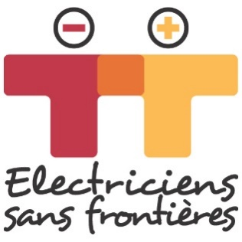

YOU'VE GOT AN IDEA FOR A PROJECT. TELL US ABOUT IT!

Thank you for your faith in us.

The purpose of this document is to enable us to identify the main characteristics of your project and to study the match between our mission and your suggestion.

Electriciens sans frontières is an international NGO that mobilizes volunteers who put their expertise at the service of sustainable actions to provide access to energy, water and economic development (lighting, water pumping, economic activities, etc.) within the framework of development projects that benefit the poorest populations. We intervene in support of project management, leading training and/or project management.

Electriciens sans frontières is neither a financial donor nor an organization responsible for supplying equipment.

If it meets our criteria, it will be offered to our network of volunteers via the various regional delegations carrying out development projects. The team of volunteers will contact you in order to jointly prepare a more complete dossier (technical and socio-economic study, assembly of an implementation dossier according to the options chosen, search for funding, implementation).

Please note: being contacted by a volunteer does not guarantee that the project will be carried out. The dossier must be examined and approved by our decision-making bodies.

The Electriciens sans frontières’ team

Date of your request: Click here to enter a date.

CONTACT

Organisation : Click here to enter text.
Date of its creation: Click here to enter a date.
Organisation’s address: Click here to enter text.
Projects already completed: Click here to enter text.
Areas where it intervenes: Click here to enter text.
Name of your contact person for Electriciens sans frontières: Click here to enter text.
His or her role within the organisation: Click here to enter text.
Email : Click here to enter text.
Telephone : Click here to enter text
Organisation's website (if there is one): Click here to enter text.

How did you hear about Electriciens sans Frontières?
Click here to enter text.

THE PROJET

Summary of the project and its origin:
Click here to enter text.
Country : Click here to enter text.
Region : Click here to enter text.
Town/Village : Click here to enter text.
Is the village connected to the electrical grid? Click here to enter text.
What are the water supply sources? Click here to enter text.
Nature of the area: ☐urban ☐suburban ☐rural

Facilities concerned (maternity clinic, health centre, school, etc.):
Click here to enter text.

What are the expressed needs and who expressed them?
Click here to enter text.

In a few lines, what is the project's aim?
Click here to enter text.

Who are the project's beneficiaries/users? What will be the impacts of this project on their living conditions?
Click here to enter text.

What, specifically, do you want from Electriciens sans frontières?
Click here to enter text.

Partners who are already involved
Click here to enter text.

Other partners being approached
Click here to enter text.

Total estimated annual and overall budget in euros (expenses and resources)
Show the project's overall forecast budget (resources/expenses) providing essential explanations. If possible, calculate or estimate what fraction of the project's budget would involve Electriciens sans frontières.

What are your thoughts on the possible sustainability of the project? Are there management committees and/or other groups already in being?
Click here to enter text.

Compliance of the action with local, regional and national policies
Are the local authorities aware of the project? Is this project being supported? By whom?

